**WEEK-2**

**TDD USING JUnit5 AND Mockito**

**Exercise 1: Setting Up Junit**

**File name: pom.xml**

<?xml version="1.0" encoding="UTF-8"?>

<project xmlns="http://maven.apache.org/POM/4.0.0"

xmlns:xsi="http://www.w3.org/2001/XMLSchema-instance"

xsi:schemaLocation="http://maven.apache.org/POM/4.0.0

http://maven.apache.org/xsd/maven-4.0.0.xsd">

<modelVersion>4.0.0</modelVersion>

<groupId>com.example</groupId>

<artifactId>junit-demo</artifactId>

<version>1.0-SNAPSHOT</version>

<packaging>jar</packaging>

<properties>

<maven.compiler.source>11</maven.compiler.source>

<maven.compiler.target>11</maven.compiler.target>

<project.build.sourceEncoding>UTF-8</project.build.sourceEncoding>

<junit.version>4.13.2</junit.version>

</properties>

<dependencies>

<!-- JUnit 4 for testing -->

<dependency>

<groupId>junit</groupId>

<artifactId>junit</artifactId>

<version>${junit.version}</version>

<scope>test</scope>

</dependency>

</dependencies>

<build>

<plugins>

<!-- Maven Compiler Plugin -->

<plugin>

<groupId>org.apache.maven.plugins</groupId>

<artifactId>maven-compiler-plugin</artifactId>

<version>3.11.0</version>

<configuration>

<source>11</source>

<target>11</target>

</configuration>

</plugin>

<!-- Maven Surefire Plugin for running tests -->

<plugin>

<groupId>org.apache.maven.plugins</groupId>

<artifactId>maven-surefire-plugin</artifactId>

<version>3.0.0</version>

</plugin>

</plugins>

</build>

</project>

**File name:Calculator.java**

package com.exercise1;

public class Calculator {

public int add(int a, int b) {

return a + b;

}

public int subtract(int a, int b) {

return a - b;

}

public int multiply(int a, int b) {

return a * b;

}

public double divide(int a, int b) {

if (b == 0) {

throw new IllegalArgumentException("Cannot divide by zero");

}

return (double) a / b;

}

public boolean isEven(int number) {

return number % 2 == 0;

}

}

**File name:CalculatorTest.java**

package com.exercise1;

import org.junit.Test;

import org.junit.Before;

import org.junit.After;

import static org.junit.Assert.*;

public class CalculatorTest {

private Calculator calculator;

@Before

public void setUp() {

// This method runs before each test method

calculator = new Calculator();

System.out.println("Setting up test...");

}

@After

public void tearDown() {

System.out.println("Cleaning up after test...");

}

@Test

public void testAdd() {

int result = calculator.add(5, 3);

assertEquals(8, result);

assertEquals(-2, calculator.add(-5, 3));

assertEquals(0, calculator.add(0, 0));

}

@Test

public void testSubtract() {

assertEquals(2, calculator.subtract(5, 3));

assertEquals(-8, calculator.subtract(-5, 3));

assertEquals(5, calculator.subtract(5, 0));

}

@Test

public void testMultiply() {

assertEquals(15, calculator.multiply(5, 3));

assertEquals(0, calculator.multiply(5, 0));

assertEquals(-15, calculator.multiply(-5, 3));

}

@Test

public void testDivide() {

assertEquals(2.5, calculator.divide(5, 2), 0.001);

assertEquals(-2.5, calculator.divide(-5, 2), 0.001);

}

@Test(expected = IllegalArgumentException.class)

public void testDivideByZero() {

calculator.divide(5, 0);

}

@Test

public void testIsEven() {

assertTrue(calculator.isEven(4));

assertFalse(calculator.isEven(5));

assertTrue(calculator.isEven(0));

assertFalse(calculator.isEven(-3));

}

}

**Output:**

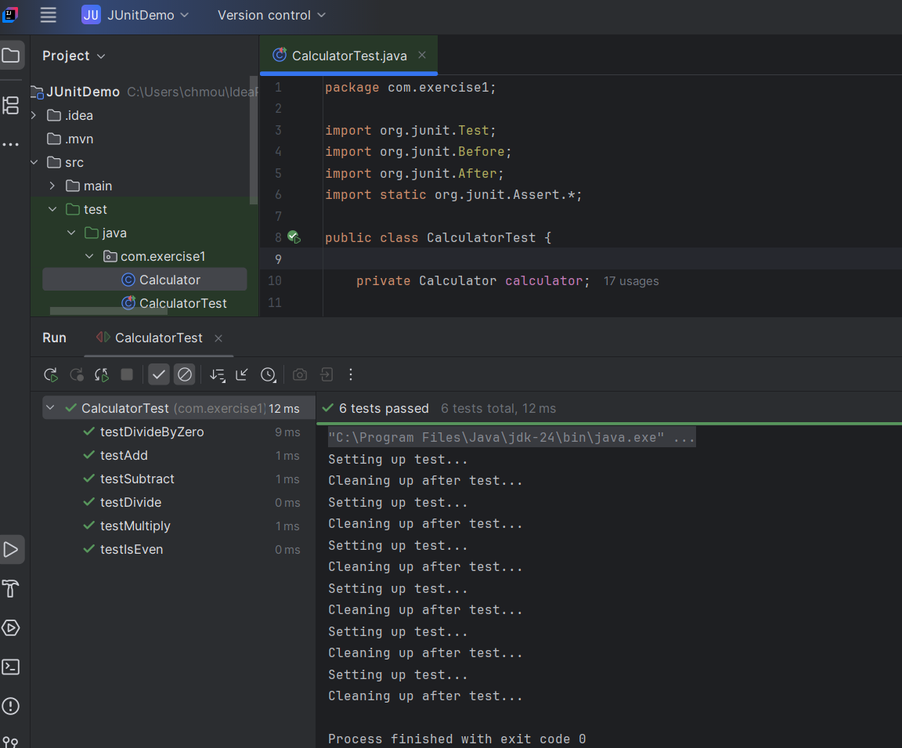

**Exercise 3: Assertions in JUnit Scenario**

**File name:pom.xml**

<?xml version="1.0" encoding="UTF-8"?>

<project xmlns="http://maven.apache.org/POM/4.0.0"

xmlns:xsi="http://www.w3.org/2001/XMLSchema-instance"

xsi:schemaLocation="http://maven.apache.org/POM/4.0.0

http://maven.apache.org/xsd/maven-4.0.0.xsd">

<modelVersion>4.0.0</modelVersion>

<groupId>com.example</groupId>

<artifactId>junit-assertions-demo</artifactId>

<version>1.0-SNAPSHOT</version>

<properties>

<maven.compiler.source>11</maven.compiler.source>

<maven.compiler.target>11</maven.compiler.target>

<junit.version>5.9.2</junit.version>

</properties>

<dependencies>

<dependency>

<groupId>org.junit.jupiter</groupId>

<artifactId>junit-jupiter</artifactId>

<version>${junit.version}</version>

<scope>test</scope>

</dependency>

<dependency>

<groupId>junit</groupId>

<artifactId>junit</artifactId>

<version>4.13.2</version>

<scope>compile</scope>

</dependency>

<dependency>

<groupId>org.testng</groupId>

<artifactId>testng</artifactId>

<version>7.11.0</version>

<scope>compile</scope>

</dependency>

</dependencies>

<build>

<plugins>

<plugin>

<groupId>org.apache.maven.plugins</groupId>

<artifactId>maven-surefire-plugin</artifactId>

<version>3.0.0-M9</version>

</plugin>

</plugins>

</build>

</project>

**File name:AssertionsTest.java**

package com.exercise3;

import org.junit.Test;

import org.junit.jupiter.api.DisplayName;

import static org.junit.jupiter.api.Assertions.*;

public class AssertionsTest {

@Test

@DisplayName("Testing various JUnit assertions")

public void testAssertions() {

assertEquals(5, 2 + 3, "2 + 3 should equal 5");

assertEquals("Hello", "Hello", "Strings should be equal");

assertTrue(5 > 3, "5 should be greater than 3");

assertTrue("Java".contains("a"), "Java should contain 'a'");

assertFalse(5 < 3, "5 should not be less than 3");

assertFalse("Java".isEmpty(), "Java string should not be empty");

String nullString = null;

assertNull(nullString, "String should be null");

assertNotNull(new Object(), "Object should not be null");

assertNotNull("Hello", "String should not be null");

}

@Test

@DisplayName("Testing additional assertion methods")

public void testMoreAssertions() {

String str1 = "Hello";

String str2 = str1;

assertSame(str1, str2, "References should point to same object");

String str3 = new String("Hello");

String str4 = new String("Hello");

assertNotSame(str3, str4, "References should point to different objects");

int[] expected = {1, 2, 3};

int[] actual = {1, 2, 3};

assertArrayEquals(expected, actual, "Arrays should be equal");

assertThrows(ArithmeticException.class, () -> {

int result = 10 / 0;

}, "Should throw ArithmeticException for division by zero");

assertTimeout(java.time.Duration.ofSeconds(2), () -> {

Thread.sleep(1000);

}, "Operation should complete within 2 seconds");

}

@Test

@DisplayName("Testing assertion with custom messages")

public void testAssertionsWithMessages() {

String name = "John";

int age = 25;

assertEquals("John", name, () -> "Expected name to be John but was: " + name);

assertTrue(age >= 18, () -> "Person should be adult, age: " + age);

}

}

**Output:**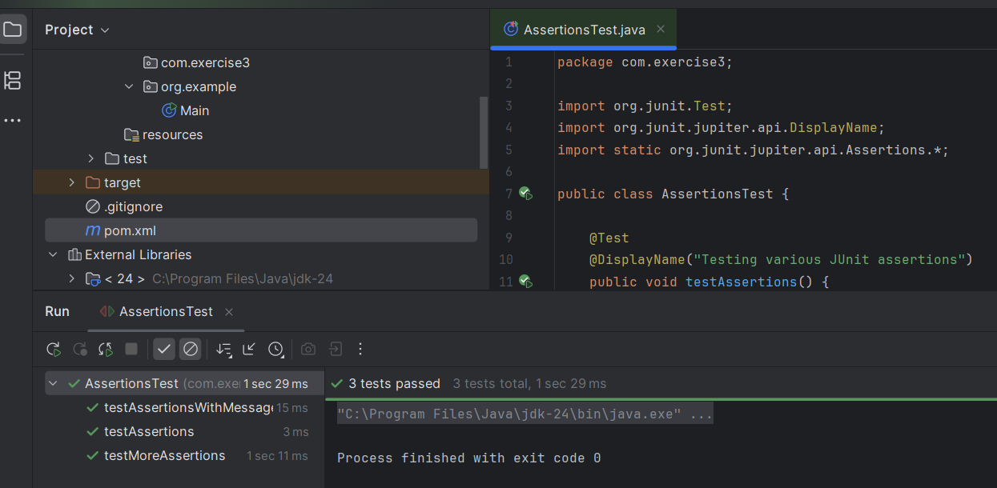

**Exercise 4: Arrange-Act-Assert (AAA) Pattern, Test Fixtures, Setup and**

**Teardown Methods in JUnit**

**File name:pom.xml**

<project xmlns="http://maven.apache.org/POM/4.0.0"

xmlns:xsi="http://www.w3.org/2001/XMLSchema-instance"

xsi:schemaLocation="http://maven.apache.org/POM/4.0.0

http://maven.apache.org/xsd/maven-4.0.0.xsd">

<modelVersion>4.0.0</modelVersion>

<groupId>com.example</groupId>

<artifactId>BankAccountApp</artifactId>

<version>1.0-SNAPSHOT</version>

<dependencies>

<!-- JUnit 4 for testing -->

<dependency>

<groupId>junit</groupId>

<artifactId>junit</artifactId>

<version>4.13.2</version>

<scope>test</scope>

</dependency>

</dependencies>

<build>

<pluginManagement>

<plugins>

<!-- Compiler plugin to use Java 8 or above -->

<plugin>

<groupId>org.apache.maven.plugins</groupId>

<artifactId>maven-compiler-plugin</artifactId>

<version>3.8.1</version>

<configuration>

<source>1.8</source>

<target>1.8</target>

</configuration>

</plugin>

</plugins>

</pluginManagement>

</build>

</project>

**File name:BankAccount.java**

package org.exercise4;

public class BankAccount {

private String accountNumber;

private double balance;

private String ownerName;

private boolean isActive;

public BankAccount(String accountNumber, String ownerName, double initialBalance) {

this.accountNumber = accountNumber;

this.ownerName = ownerName;

this.balance = initialBalance;

this.isActive = true;

}

public void deposit(double amount) {

if (!isActive) {

throw new IllegalStateException("Account is not active");

}

if (amount <= 0) {

throw new IllegalArgumentException("Deposit amount must be positive");

}

balance += amount;

}

public void withdraw(double amount) {

if (!isActive) {

throw new IllegalStateException("Account is not active");

}

if (amount <= 0) {

throw new IllegalArgumentException("Withdrawal amount must be positive");

}

if (amount > balance) {

throw new IllegalArgumentException("Insufficient funds");

}

balance -= amount;

}

public double getBalance() {

return balance;

}

public String getAccountNumber() {

return accountNumber;

}

public String getOwnerName() {

return ownerName;

}

public boolean isActive() {

return isActive;

}

public void closeAccount() {

isActive = false;

}

public void transfer(BankAccount targetAccount, double amount) {

this.withdraw(amount);

targetAccount.deposit(amount);

}

}

**File name:BankAccountTest.java**

import org.junit.*;

import static org.junit.Assert.*;

import org.exercise4.BankAccount;

public class BankAccountTest {

// Test fixtures - shared test data

private BankAccount sourceAccount;

private BankAccount targetAccount;

private final String TEST_ACCOUNT_1 = "ACC001";

private final String TEST_ACCOUNT_2 = "ACC002";

private final String OWNER_NAME_1 = "John Doe";

private final String OWNER_NAME_2 = "Jane Smith";

private final double INITIAL_BALANCE = 1000.0;

// Setup method - runs before each test

@Before

public void setUp() {

System.out.println("Setting up test fixtures...");

// Initialize test objects

sourceAccount = new BankAccount(TEST_ACCOUNT_1, OWNER_NAME_1, INITIAL_BALANCE);

targetAccount = new BankAccount(TEST_ACCOUNT_2, OWNER_NAME_2, 500.0);

System.out.println("Test fixtures ready");

}

// Teardown method - runs after each test

@After

public void tearDown() {

System.out.println("Cleaning up test fixtures...");

// Clean up resources

sourceAccount = null;

targetAccount = null;

System.out.println("Test cleanup completed");

}

// Setup method - runs once before all tests in the class

@BeforeClass

public static void setUpClass() {

System.out.println("=== Starting BankAccount Test Suite ===");

}

// Teardown method - runs once after all tests in the class

@AfterClass

public static void tearDownClass() {

System.out.println("=== BankAccount Test Suite Completed ===");

}

@Test

public void testDeposit_ValidAmount_IncreasesBalance() {

// ARRANGE

double depositAmount = 250.0;

double expectedBalance = INITIAL_BALANCE + depositAmount;

// ACT

sourceAccount.deposit(depositAmount);

// ASSERT

assertEquals("Balance should increase by deposit amount",

expectedBalance, sourceAccount.getBalance(), 0.01);

}

@Test

public void testWithdraw_ValidAmount_DecreasesBalance() {

// ARRANGE

double withdrawAmount = 300.0;

double expectedBalance = INITIAL_BALANCE - withdrawAmount;

// ACT

sourceAccount.withdraw(withdrawAmount);

// ASSERT

assertEquals("Balance should decrease by withdrawal amount",

expectedBalance, sourceAccount.getBalance(), 0.01);

}

@Test(expected = IllegalArgumentException.class)

public void testWithdraw_InsufficientFunds_ThrowsException() {

// ARRANGE

double withdrawAmount = INITIAL_BALANCE + 100.0; // More than available

// ACT

sourceAccount.withdraw(withdrawAmount);

// ASSERT - Exception expected (handled by annotation)

}

@Test(expected = IllegalArgumentException.class)

public void testDeposit_NegativeAmount_ThrowsException() {

// ARRANGE

double negativeAmount = -50.0;

// ACT

sourceAccount.deposit(negativeAmount);

// ASSERT - Exception expected (handled by annotation)

}

@Test

public void testTransfer_ValidAmount_UpdatesBothAccounts() {

// ARRANGE

double transferAmount = 200.0;

double expectedSourceBalance = INITIAL_BALANCE - transferAmount;

double expectedTargetBalance = 500.0 + transferAmount;

// ACT

sourceAccount.transfer(targetAccount, transferAmount);

// ASSERT

assertEquals("Source account balance should decrease",

expectedSourceBalance, sourceAccount.getBalance(), 0.01);

assertEquals("Target account balance should increase",

expectedTargetBalance, targetAccount.getBalance(), 0.01);

}

@Test

public void testCloseAccount_ActiveAccount_DeactivatesAccount() {

// ARRANGE

assertTrue("Account should initially be active", sourceAccount.isActive());

// ACT

sourceAccount.closeAccount();

// ASSERT

assertFalse("Account should be inactive after closing", sourceAccount.isActive());

}

@Test(expected = IllegalStateException.class)

public void testDeposit_InactiveAccount_ThrowsException() {

// ARRANGE

sourceAccount.closeAccount(); // Make account inactive

double depositAmount = 100.0;

// ACT

sourceAccount.deposit(depositAmount);

// ASSERT - Exception expected (handled by annotation)

}

@Test

public void testAccountCreation_ValidParameters_SetsPropertiesCorrectly() {

// ARRANGE

String accountNumber = "TEST123";

String ownerName = "Test Owner";

double initialBalance = 750.0;

// ACT

BankAccount newAccount = new BankAccount(accountNumber, ownerName, initialBalance);

// ASSERT

assertEquals("Account number should match", accountNumber, newAccount.getAccountNumber());

assertEquals("Owner name should match", ownerName, newAccount.getOwnerName());

assertEquals("Initial balance should match", initialBalance, newAccount.getBalance(), 0.01);

assertTrue("New account should be active", newAccount.isActive());

}

@Test

public void testMultipleDeposits_ValidAmounts_AccumulatesCorrectly() {

// ARRANGE

double deposit1 = 100.0;

double deposit2 = 150.0;

double deposit3 = 75.0;

double expectedFinalBalance = INITIAL_BALANCE + deposit1 + deposit2 + deposit3;

// ACT

sourceAccount.deposit(deposit1);

sourceAccount.deposit(deposit2);

sourceAccount.deposit(deposit3);

// ASSERT

assertEquals("Multiple deposits should accumulate correctly",

expectedFinalBalance, sourceAccount.getBalance(), 0.01);

}

@Test

public void testMixedTransactions_DepositAndWithdraw_CalculatesCorrectBalance() {

// ARRANGE

double deposit1 = 200.0;

double withdrawal1 = 150.0;

double deposit2 = 100.0;

double withdrawal2 = 75.0;

double expectedBalance = INITIAL_BALANCE + deposit1 - withdrawal1 + deposit2 - withdrawal2;

sourceAccount.deposit(deposit1);

sourceAccount.withdraw(withdrawal1);

sourceAccount.deposit(deposit2);

sourceAccount.withdraw(withdrawal2);

assertEquals("Mixed transactions should calculate correct final balance",

expectedBalance, sourceAccount.getBalance(), 0.01);

}

**Output:**

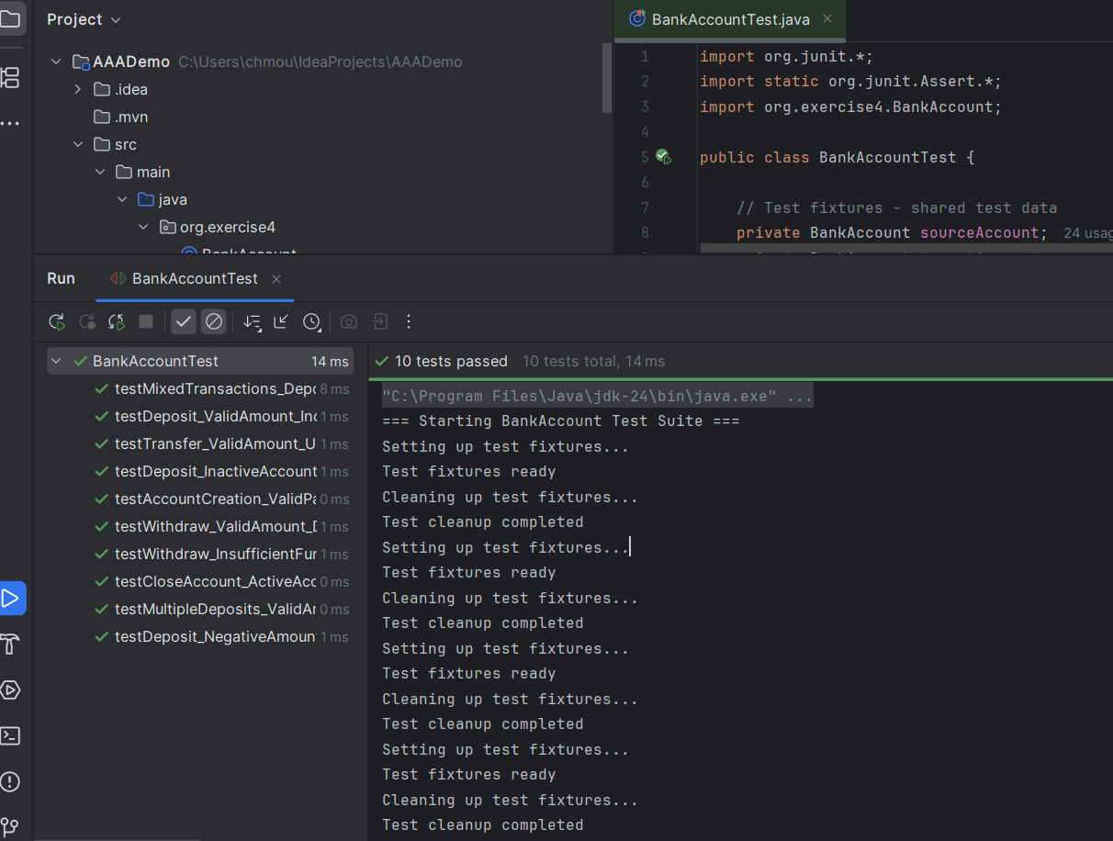

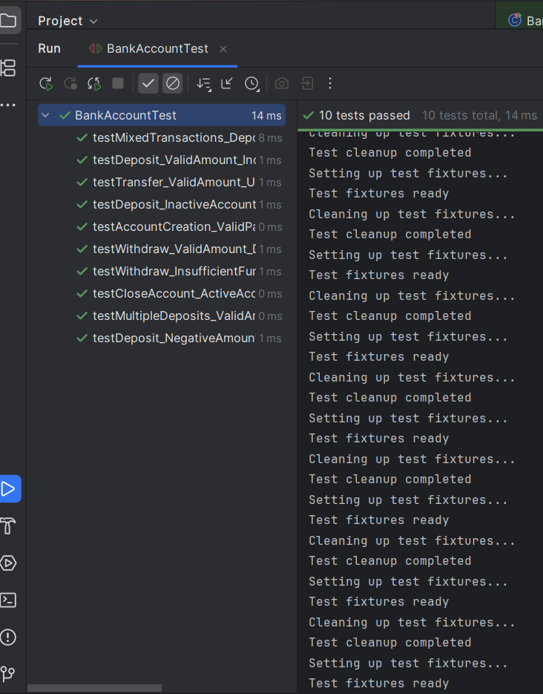

**Exercise 1: Mocking and Stubbing**

**File name:pom.xml**

<?xml version="1.0" encoding="UTF-8"?>

<project xmlns="http://maven.apache.org/POM/4.0.0"

xmlns:xsi="http://www.w3.org/2001/XMLSchema-instance"

xsi:schemaLocation="http://maven.apache.org/POM/4.0.0 http://maven.apache.org/xsd/maven-4.0.0.xsd">

<modelVersion>4.0.0</modelVersion>

<groupId>com.exercise1</groupId>

<artifactId>MockingAndStubbing</artifactId>

<version>1.0-SNAPSHOT</version>

<properties>

<maven.compiler.source>21</maven.compiler.source>

<maven.compiler.target>21</maven.compiler.target>

<project.build.sourceEncoding>UTF-8</project.build.sourceEncoding>

</properties>

<dependencies>

<!-- JUnit 5 -->

<dependency>

<groupId>org.junit.jupiter</groupId>

<artifactId>junit-jupiter</artifactId>

<version>5.10.0</version>

<scope>test</scope>

</dependency>

<!-- Mockito -->

<dependency>

<groupId>org.mockito</groupId>

<artifactId>mockito-core</artifactId>

<version>5.12.0</version>

<scope>test</scope>

</dependency>

</dependencies>

</project>

**File name:MyService.java**

package com.exercise1

public class MyService {

private ExternalApi externalApi;

public MyService(ExternalApi externalApi) {

this.externalApi = externalApi;

}

public String fetchData() {

return externalApi.getData();

}

}

**File name:ExternalApi.java**

package com.exercise1;

public interface ExternalApi {

String getData();

}

**File name:MyServiceTest.java**

import static org.mockito.Mockito.*;

import static org.junit.jupiter.api.Assertions.*;

import com.exercise1.ExternalApi;

import com.exercise1.MyService;

import org.junit.jupiter.api.Test;

import org.mockito.Mockito;

public class MyServiceTest {

@Test

public void testFetchDataReturnsMockedValue() {

ExternalApi mockApi = Mockito.mock(ExternalApi.class);

when(mockApi.getData()).thenReturn("Mock Data");

MyService service = new MyService(mockApi);

String result = service.fetchData()

assertEquals("Mock Data", result);

}

}

**Output:**

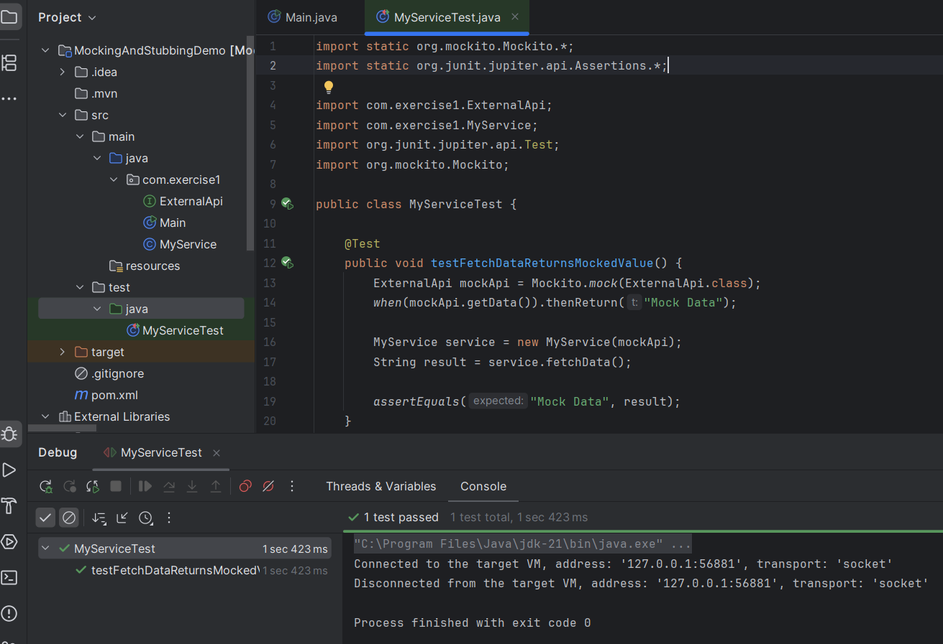

**Exercise 2: Verifying Interactions**

**File name:pom.xml**

<?xml version="1.0" encoding="UTF-8"?>

<project xmlns="http://maven.apache.org/POM/4.0.0"

xmlns:xsi="http://www.w3.org/2001/XMLSchema-instance"

xsi:schemaLocation="http://maven.apache.org/POM/4.0.0

http://maven.apache.org/xsd/maven-4.0.0.xsd">

<modelVersion>4.0.0</modelVersion>

<groupId>com.exercise2</groupId>

<artifactId>mockito-verification-demo</artifactId>

<version>1.0.0</version>

<packaging>jar</packaging>

<properties>

<maven.compiler.source>21</maven.compiler.source>

<maven.compiler.target>21</maven.compiler.target>

<project.build.sourceEncoding>UTF-8</project.build.sourceEncoding>

<junit.version>5.10.1</junit.version>

<mockito.version>5.8.0</mockito.version>

</properties>

<dependencies>

<dependency>

<groupId>org.junit.jupiter</groupId>

<artifactId>junit-jupiter</artifactId>

<version>${junit.version}</version>

<scope>test</scope>

</dependency>

<dependency>

<groupId>org.mockito</groupId>

<artifactId>mockito-core</artifactId>

<version>${mockito.version}</version>

<scope>test</scope>

</dependency>

<dependency>

<groupId>org.mockito</groupId>

<artifactId>mockito-junit-jupiter</artifactId>

<version>${mockito.version}</version>

<scope>test</scope>

</dependency>

</dependencies>

<build>

<plugins>

<plugin>

<groupId>org.apache.maven.plugins</groupId>

<artifactId>maven-compiler-plugin</artifactId>

<version>3.11.0</version>

<configuration>

<source>21</source>

<target>21</target>

</configuration>

</plugin>

<plugin>

<groupId>org.apache.maven.plugins</groupId>

<artifactId>maven-surefire-plugin</artifactId>

<version>3.2.2</version>

<configuration>

<argLine>

-XX:+EnableDynamicAgentLoading

-Djdk.instrument.traceUsage=false

-Xshare:off

</argLine>

</configuration>

</plugin>

</plugins>

</build>

</project>

**File name:MyService.java**

package com.exercise2;

public class MyService {

private final ExternalApi externalApi;

public MyService(ExternalApi externalApi) {

this.externalApi = externalApi;

}

public String fetchData() {

return externalApi.getData();

}

public String fetchDataWithParameter(String param) {

return externalApi.getData(param);

}

public void saveUserData(String userData) {

externalApi.saveData(userData);

}

public boolean processUserData(String data, int times) {

return externalApi.processData(data, times);

}

}

**File name:MyServiceTest.java**

import static org.mockito.Mockito.*;

import com.exercise2.ExternalApi;

import com.exercise2.MyService;

import org.junit.jupiter.api.Test;

import org.junit.jupiter.api.BeforeEach;

import org.junit.jupiter.api.extension.ExtendWith;

import org.mockito.Mock;

import org.mockito.junit.jupiter.MockitoExtension

@ExtendWith(MockitoExtension.class)

public class MyServiceTest {

@Mock

private ExternalApi mockApi;

private MyService service;

@BeforeEach

void setUp() {

service = new MyService(mockApi);

}

@Test

public void testVerifyInteraction() {

service.fetchData();

verify(mockApi).getData();

}

@Test

public void shouldVerifyMethodCalledWithSpecificArguments() {

String userInput = "customer_data";

service.fetchDataWithParameter(userInput);

verify(mockApi).getData(userInput);

}

@Test

public void shouldVerifyMultipleMethodCalls() {

String userData = "john_doe_profile";

service.saveUserData(userData);

service.fetchData();

verify(mockApi).saveData(userData);

verify(mockApi).getData();

}

@Test

public void shouldVerifyMethodWithMultipleParameters() {

String dataToProcess = "analytics_data";

int processingTimes = 3;

service.processUserData(dataToProcess, processingTimes);

verify(mockApi).processData(dataToProcess, processingTimes);

}

@Test

public void shouldConfirmNoMethodsWereCalled() {

verifyNoInteractions(mockApi);

}

@Test

public void shouldVerifyExactNumberOfCalls() {

service.fetchData();

service.fetchData();

service.fetchData();

verify(mockApi, times(3)).getData();

}

@Test

public void shouldVerifyMethodCalledAtLeastOnce() {

service.fetchData();

service.fetchData();

verify(mockApi, atLeastOnce()).getData();

@Test

public void shouldVerifyMethodNeverCalled() {

service.fetchDataWithParameter("test_param");

verify(mockApi, never()).getData();

verify(mockApi).getData("test_param");}

@Test

public void shouldVerifyUsingArgumentMatchers() {

service.fetchDataWithParameter("any_string_value");

verify(mockApi).getData(anyString());

verify(mockApi).getData(eq("any_string_value"));}

@Test

public void shouldVerifyMethodCallOrder() {

String importantData = "critical_user_data"

service.fetchData();

service.saveUserData(importantData);

var orderVerifier = inOrder(mockApi);

orderVerifier.verify(mockApi).getData();

orderVerifier.verify(mockApi).saveData(importantData); }}

**Output:**